**EXERCISES:**

* A student wants to add two complex number whose one-part real number and the another part is an imaginary number, you are asked to write a program to add these numbers with the help of operator overloading technique.
* A vector namely V1 and its x and y components is v1_x and v1_y, the second vector is V2 and it has also two components namely v2_x and v2_y, perform vector addition by using its respective components into third V3 and its components is v3_x and v3_y with the help of operator overloading.
* 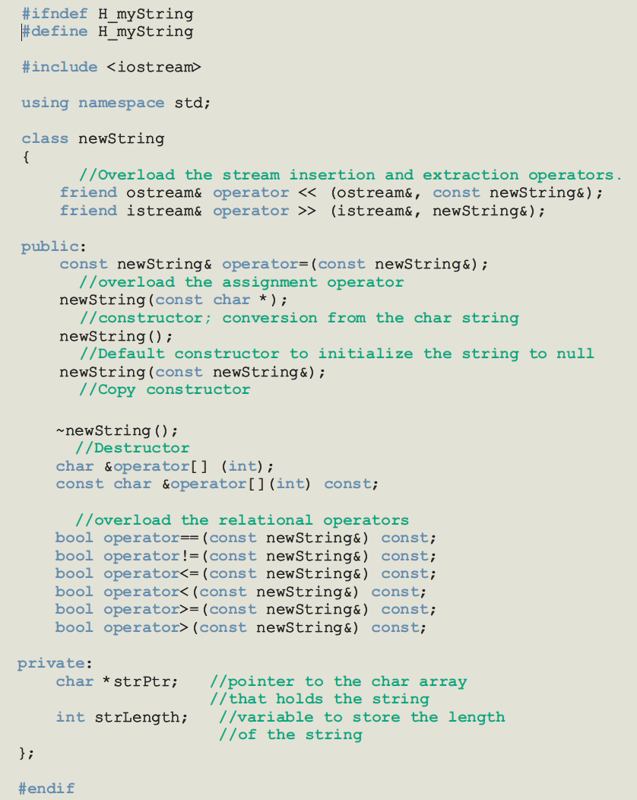Implement the following class.